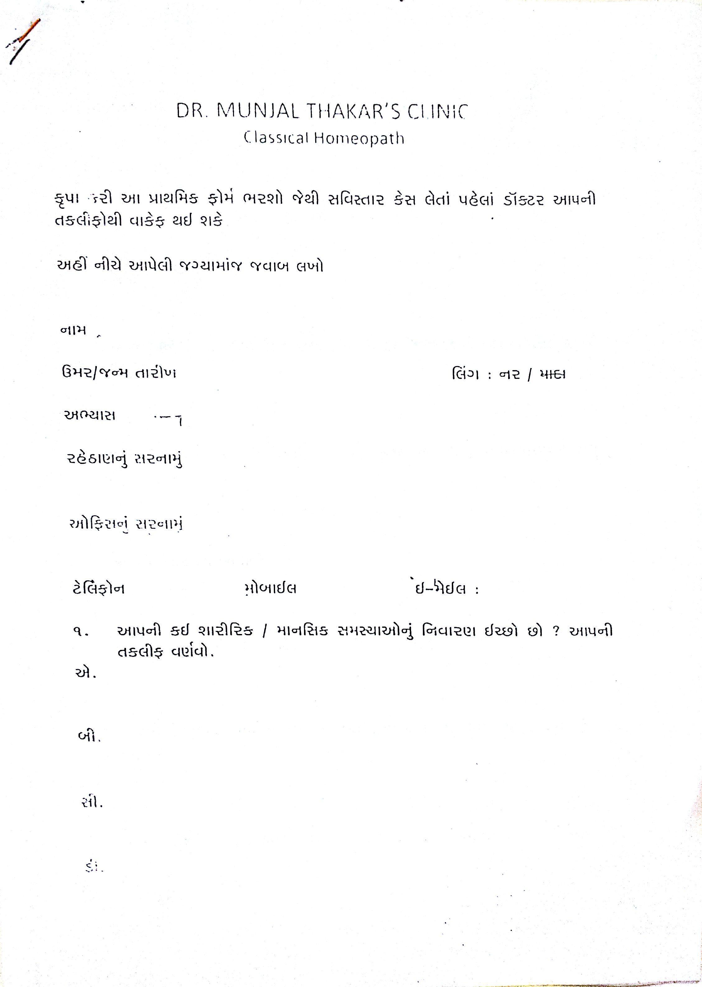

Generated by CamScanner from intsig.com

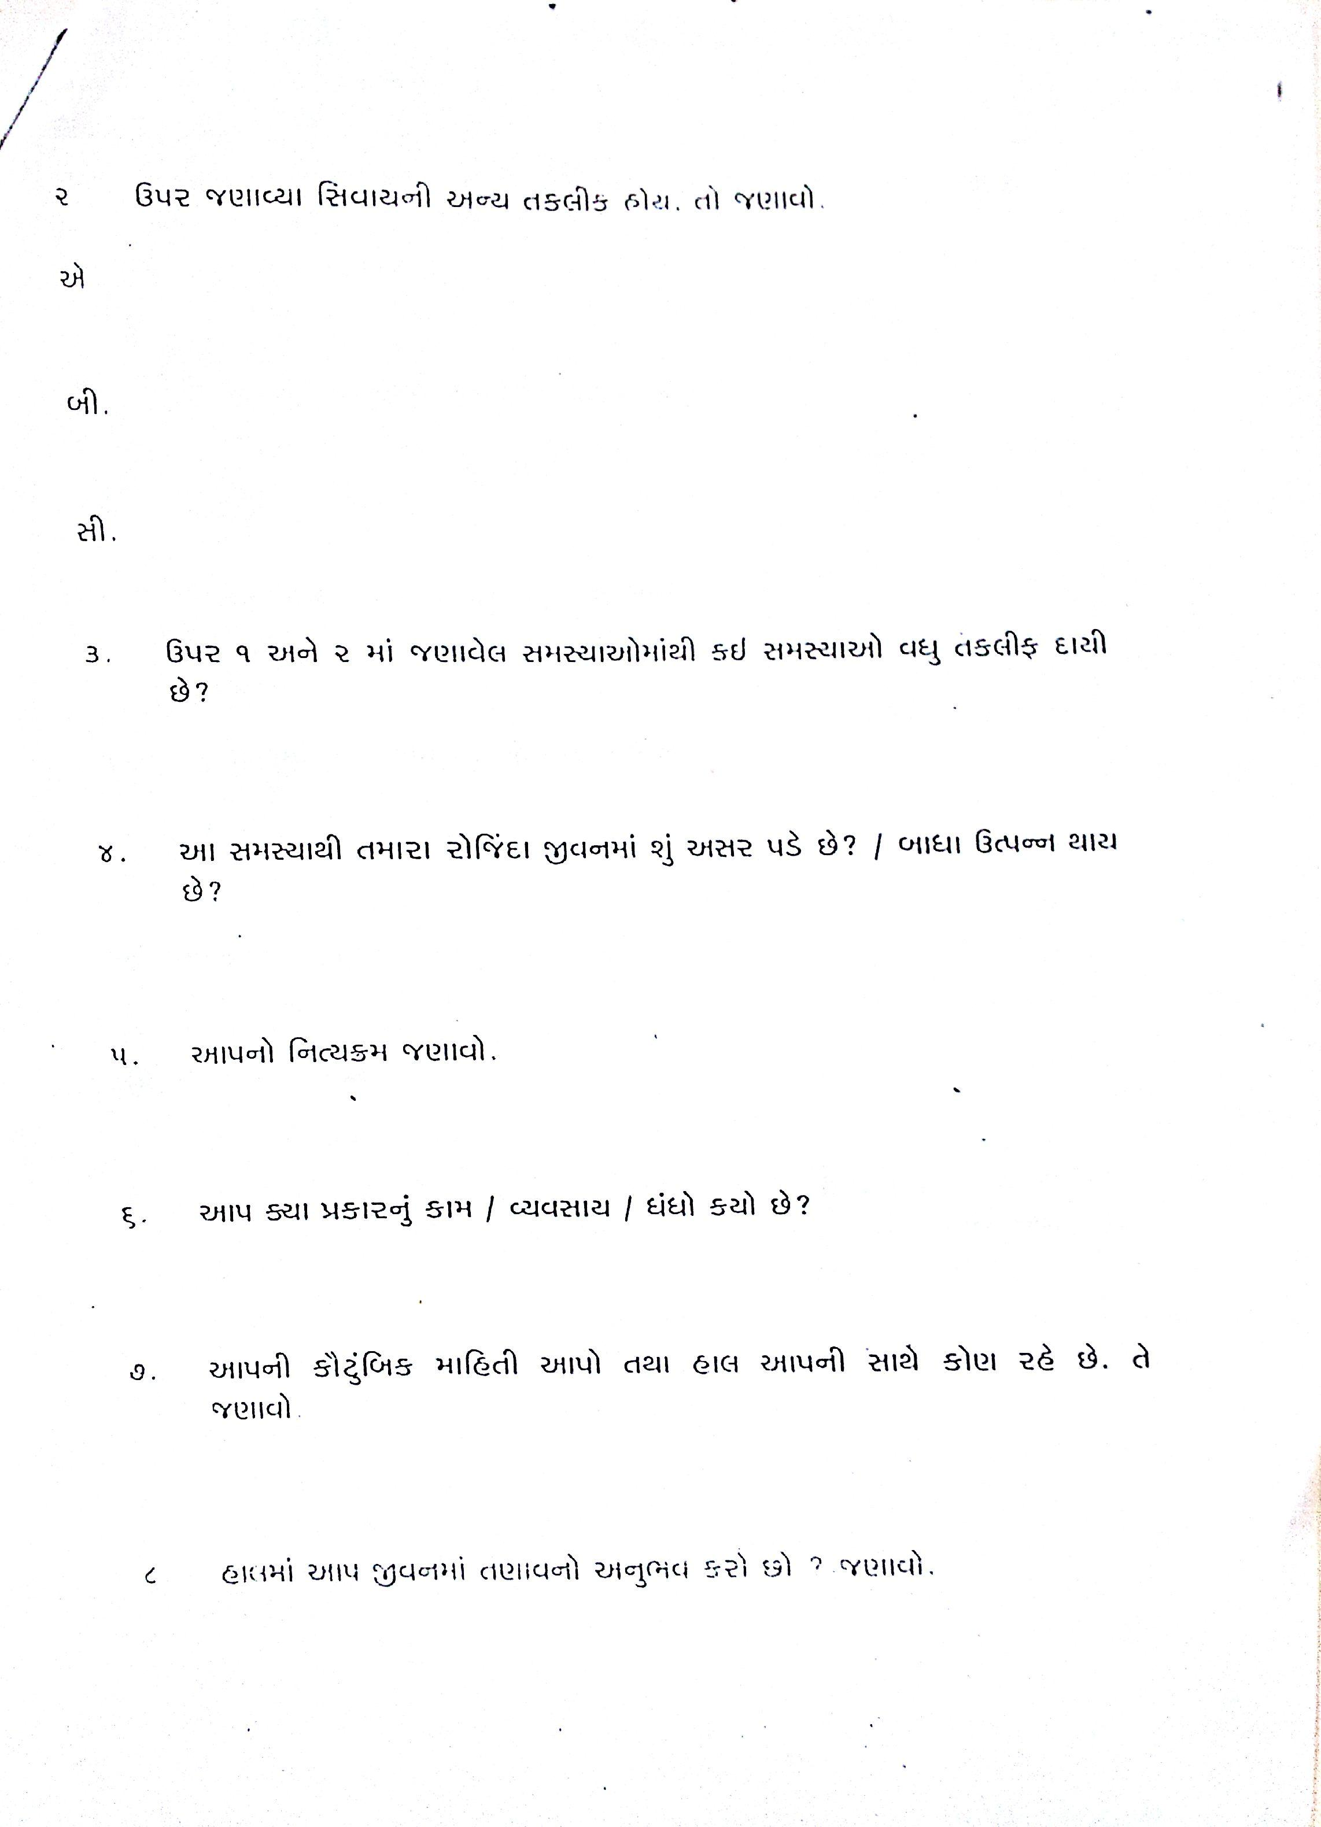

Generated by CamScanner from intsig.com

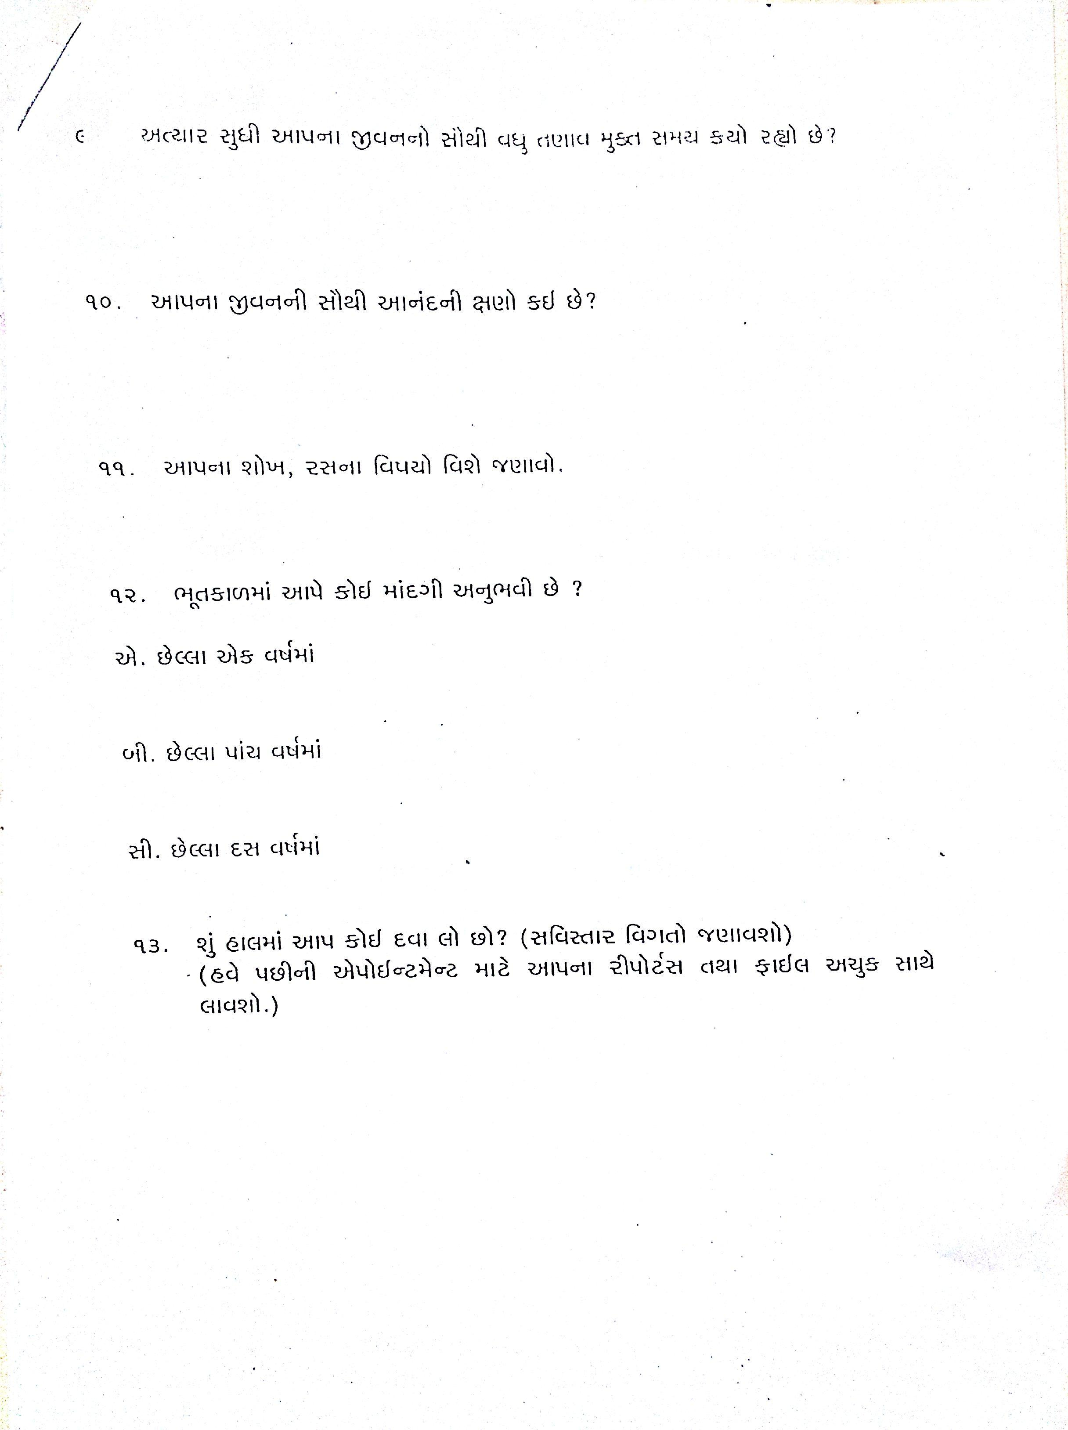

Generated by CamScanner from intsig.com

